Chapter 17, Problem 27.

For the waveform shown in Fig. 17.65 below,

- specify the type of symmetry it has,
- calculate a₃ and b₃,
- find the rms value using the first five nonzero harmonics.

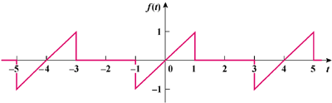

Figure 17.65
For Prob. 17.27.

